**IMPORTING ALL DATA IN TABLE FROM EXCEL**

To do this name of the excel file column and DB table column needs to be same, and also the data in excel should match the data type specified in DB table.

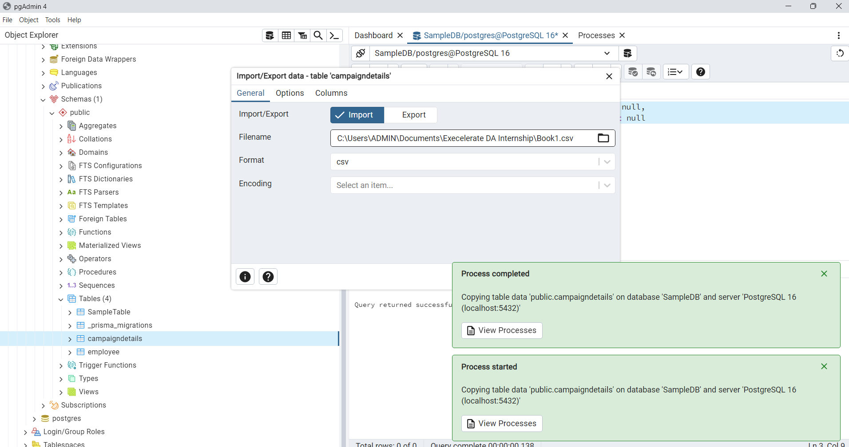



**Primary –** Doesn’t allows to generate duplicate data, data are created with unique id, it cannot be null, and allows to do foreign key reference

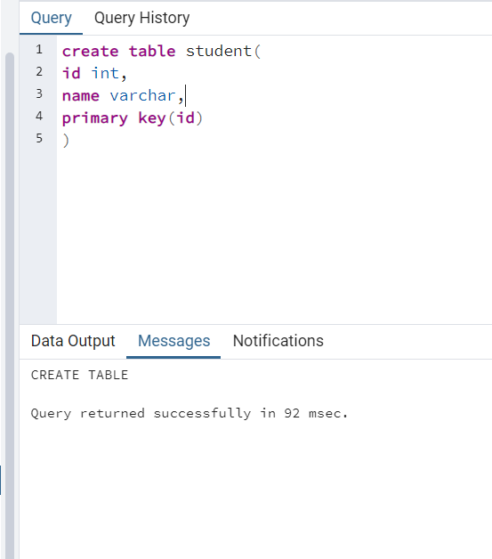

We can have only one primary key if we declare the primary key in below way

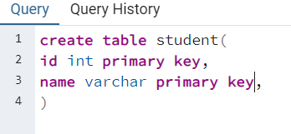

The above query throws error, while the one helps to specify allows to more combination of primary key. That is called composite(more) primary key

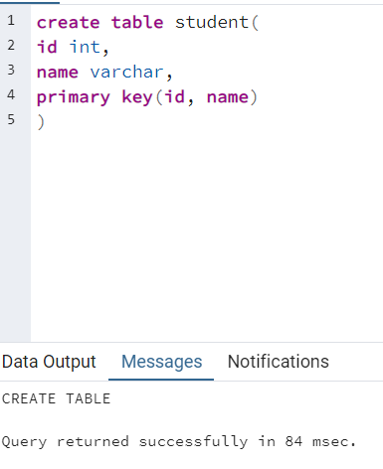

**UNIQUE CONSTRAINT**

Allows to type unique values and doesn’t allows duplicate values for specific column, the main difference between primary and unique is it allows null values

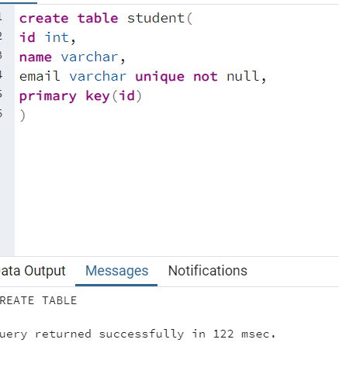

**SERIAL KEYWORD**

Allows to do auto increment for id, in mysql we have auto increment keyword for this.

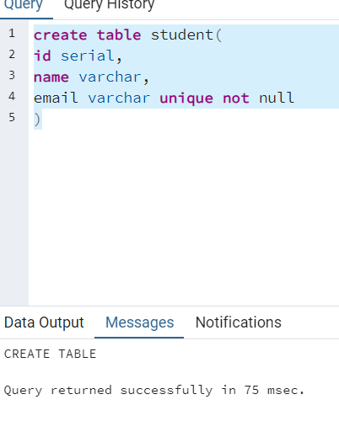

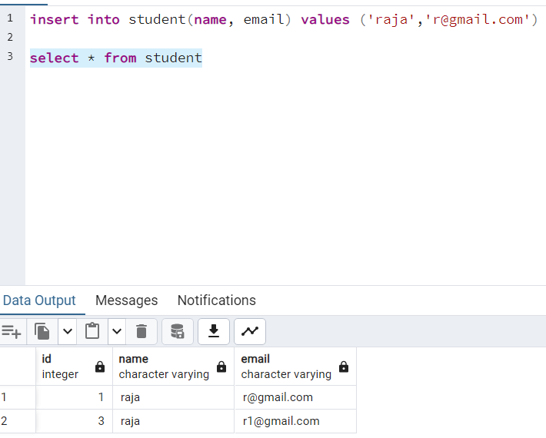

**FORIGEN KEY**

It helps to refer another table’s column which has primary key constraint, if the reference table haven’t the any primary key constraint definition then it will throw error.